SESSION 8 — Gearhaven
Beat 3 — The Artificer’s Guild

The Climb
Pinion leads you up through the winding streets, ever higher, until the houses fall away and you reach the very top of Cogtooth Hill. And there it stands: the Artificer’s Guild. It isn’t a building so much as a cathedral built around a machine — brass arches soaring overhead, glass domes catching the morning light, and through the heart of it all the Great Governor, the enormous gear-engine you saw from the ridge, turning slow and vast.
Pinion stops at the door, suddenly shy. “This is as far as I go, dearies — trams don’t drive themselves. Well. They’re not supposed to.” She pats each of you on the arm. “You go on. Ask for Vane. And… thank you. For the market. Steady gears to you.” And with that, she bustles off back down the hill.

Through the Gear-Doors
The Guild’s doors are a wonder in themselves — two slabs of brass worked with a thousand interlocking gears. As you approach they sense you and begin to turn, cogs spinning cogs, the whole pattern unwinding like a puzzle solving itself, until the doors roll smoothly apart with a deep, satisfied CHUNK. Warm golden light and the smell of oil and ozone spill out to meet you.
And then you’re inside, and you simply stop and stare. It’s a cathedral of machines. The hall soars up and up, ringed with balconies, lit by tall stained-glass windows throwing colored light across everything. Brass catwalks and rope-nets crisscross the open air; apprentices in goggles ride little platforms up and down, testing contraptions that hover, spin, and occasionally puff into harmless smoke. Mechanical birds carry rolled blueprints between balconies. And through the very center turns the Great Governor — so close now that its slow, vast heartbeat isn’t just a sound but a feeling, thrumming up through the soles of your boots. Boom. Boom. Boom.
You came looking for answers. Standing here, in the beating heart of Gearhaven’s genius, it finally feels like you might actually find them.
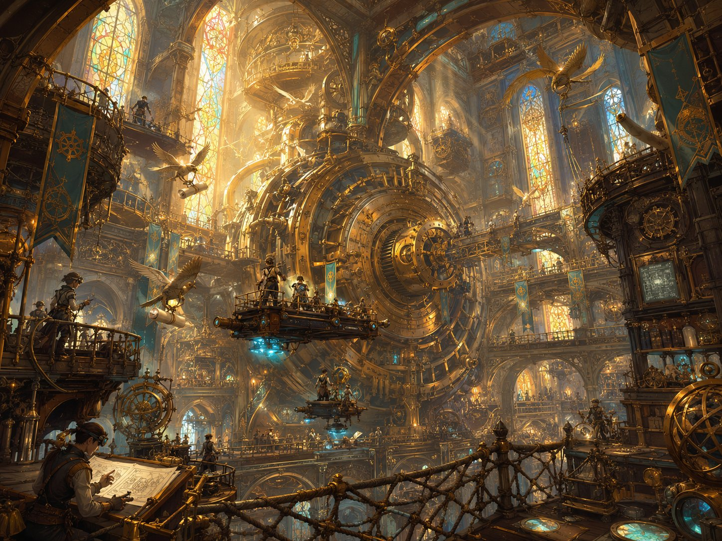
Inside the Artificer’s Guild — a cathedral built around the Great Governor.

Guildmaster Vane
Inside, you find chaos. Blueprints cover every surface. A half-built machine clanks sadly in a corner. And in the middle of it all, a wiry old man with wild white hair, ink-stained fingers, and goggles shoved up on his forehead is arguing — out loud — with a wrench.
Vane: “No, no, you go THERE, you stubborn— oh, hello! Visitors. I don’t— who let— never mind. I’m Vane. Guildmaster Vane. And you’ve caught me on a TERRIBLE week, the machines have all gone mad, half the city’s terrified, I haven’t slept in— I don’t actually know how long.”
Then something clicks behind his tired eyes. “Wait. Three young ones — a gnome, a goblin, a boy with a staff. You’re the ones from the market! You STOPPED one of those rampages.” He’s suddenly across the room, gripping Lilly’s hands, then Stabby’s, then bowing to Ursa. “Do you have any idea what a relief— you three just marched in and HELPED. Bless you. Now. Tell me everything.”
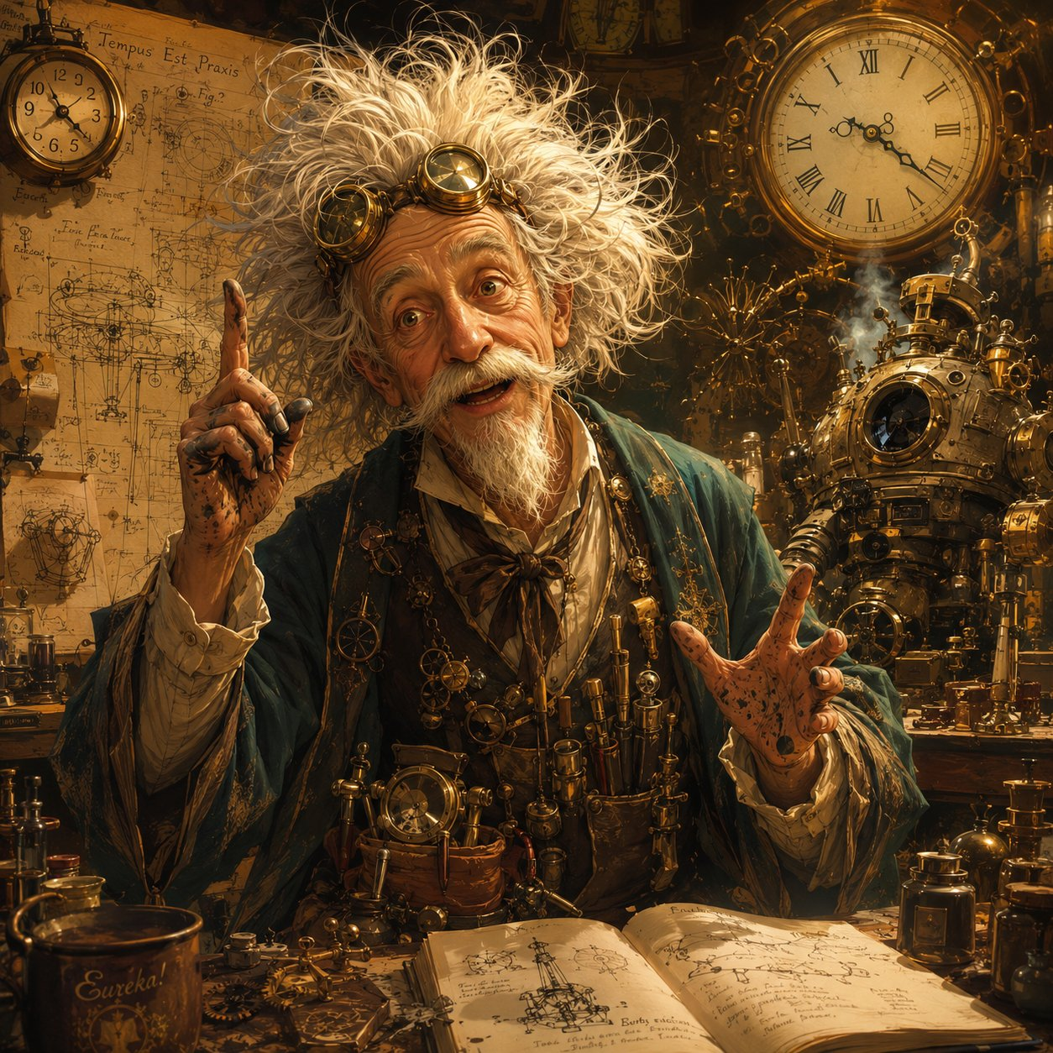
Guildmaster Vane — brilliant, scattered, sleepless.
Talk-opening. Suggested lines below.
Lilly: “We came to find you. I’m carrying something I think only the Guild can understand.”
Ursa: “We’re following the cracks in the world — and they led us here.”
Stabby: “Also your city tried to eat us this morning. You’re welcome for fixing that.”

Quill
Before Vane can launch into a dozen questions at once, a second figure glides up beside him — a tall, elegant Mechagnome of polished silver and brass, moving with calm, unhurried grace. Where Vane is a whirlwind, this one is still water.
Quill: “Forgive the Guildmaster. He forgets introductions when he’s excited — which is always. I am Quill. I keep the Guild’s records, and the Guildmaster’s head, more or less, attached to his shoulders. You are most welcome here.”
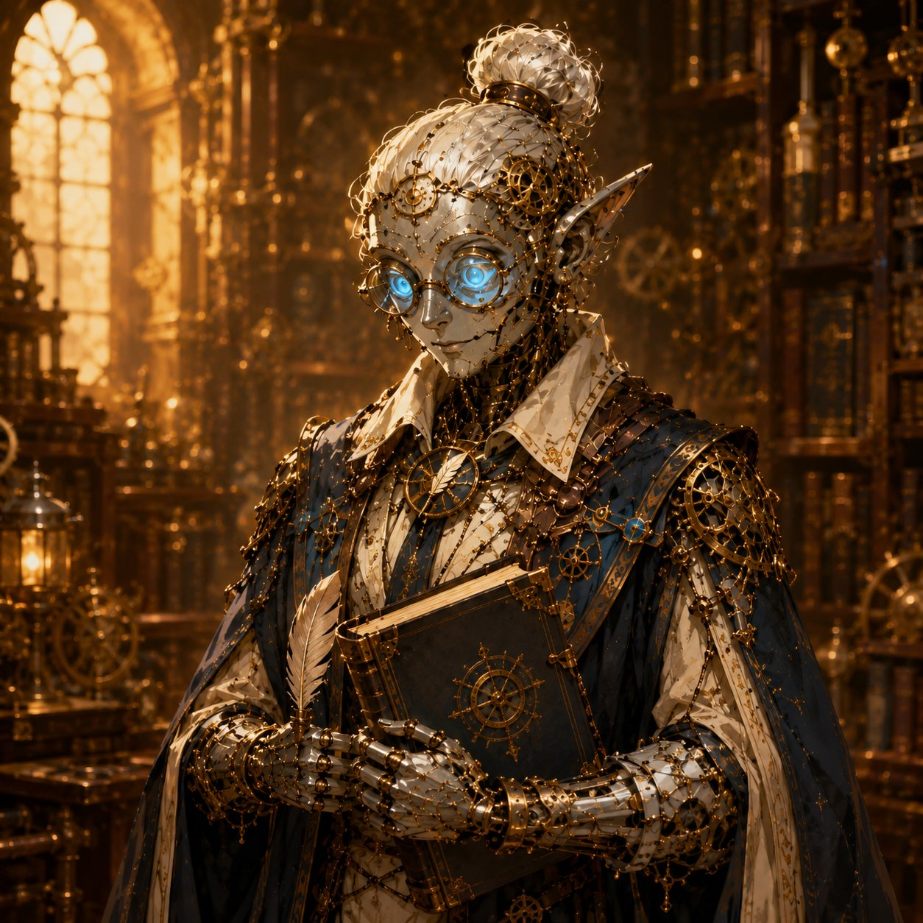
Quill, the Guild’s archivist.

The Sphere
When Lilly carefully lifts the Essence Sphere from her pack, the whole room seems to change. Vane goes utterly silent for the first time. He leans in, goggles dropping over his eyes, and breathes: “Oh. Oh my. This is Glimmerspire work. The deep-gnome masters — the finest artifice ever made. And it’s holding something… something alive.” His finger hovers, not quite touching. “But the casing’s barely open. This was built to hold so much MORE than it’s holding.”
Vane reassures them — the Sphere stays Lilly’s. Read clearly: “I would never KEEP it. If we open it, we do it together, right here, and it goes straight back in your hands. It’s yours. Now come — let me show you what I’ve been losing my mind over. Let me show you my great failure.”

Vane’s Folly
He leads you to the far end of the hall, sweeps a dust-sheet off a great shape in the corner — and there it stands. An enormous ring of brass and iron, tall enough to walk through, ringed with hundreds of intricate gears, coils of cable, and empty crystal sockets. It’s beautiful. It’s also dark, dead, silent, and thick with cobwebs. The walls around it are buried under ten years of frantic blueprints.
Vane: “My folly. A Rift Portal — a door that could carry someone TO the broken planes, to mend the cracks at their source instead of swatting mad machines in the street forever. I’ve bled ten years into this machine. And it has never so much as flickered.”
He taps an empty cradle at the portal’s center — a socket, clearly meant to hold something, achingly empty. “Raw planar energy destroys anything that tries to contain it. Anything I build to carry a traveler through, the energy tears apart in seconds. I need an anchor. A vessel that can not only SURVIVE the crossing, but hold what spills out. Ten years… and I’m still standing at a locked door, without the key.”
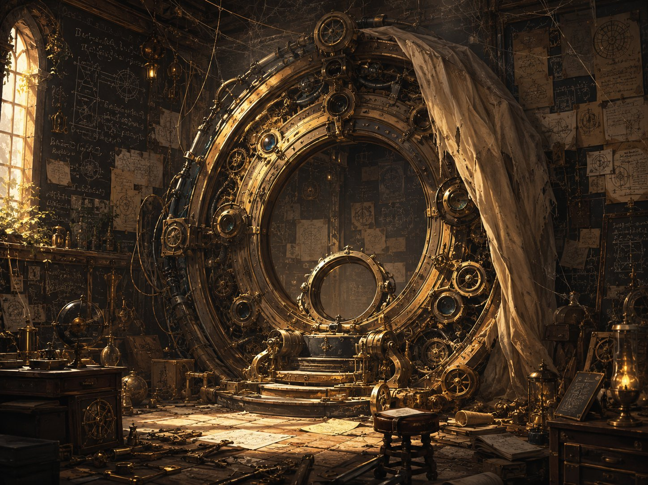
Vane’s Folly — ten years of work, and an empty cradle at its heart.

The Orrery
“And the worst part,” he says, towing you toward the grandest machine in the room, “is that I know exactly how bad it’s getting.” A brass orrery tall as a tree — rings within rings, a glowing glass globe floating at the center. “The world,” he taps the globe. “And around it, the other planes — Fire, Water, Air, Earth, Shadow — spinning in perfect time, like the gears of a great clock. For a thousand years, perfect time.” He pulls a lever. The orrery speeds up — and now you see it: here and there a gear catches, slips, grinds. Sickly green light leaks from the seams, and tiny glowing crystal motes shake loose and tumble from their orbits. “But the clock is breaking. The planes slip; they crack; things fall through. Those motes are pieces of the planes themselves, leaking into our world. THAT is what drives my machines mad. And it is only getting worse.”
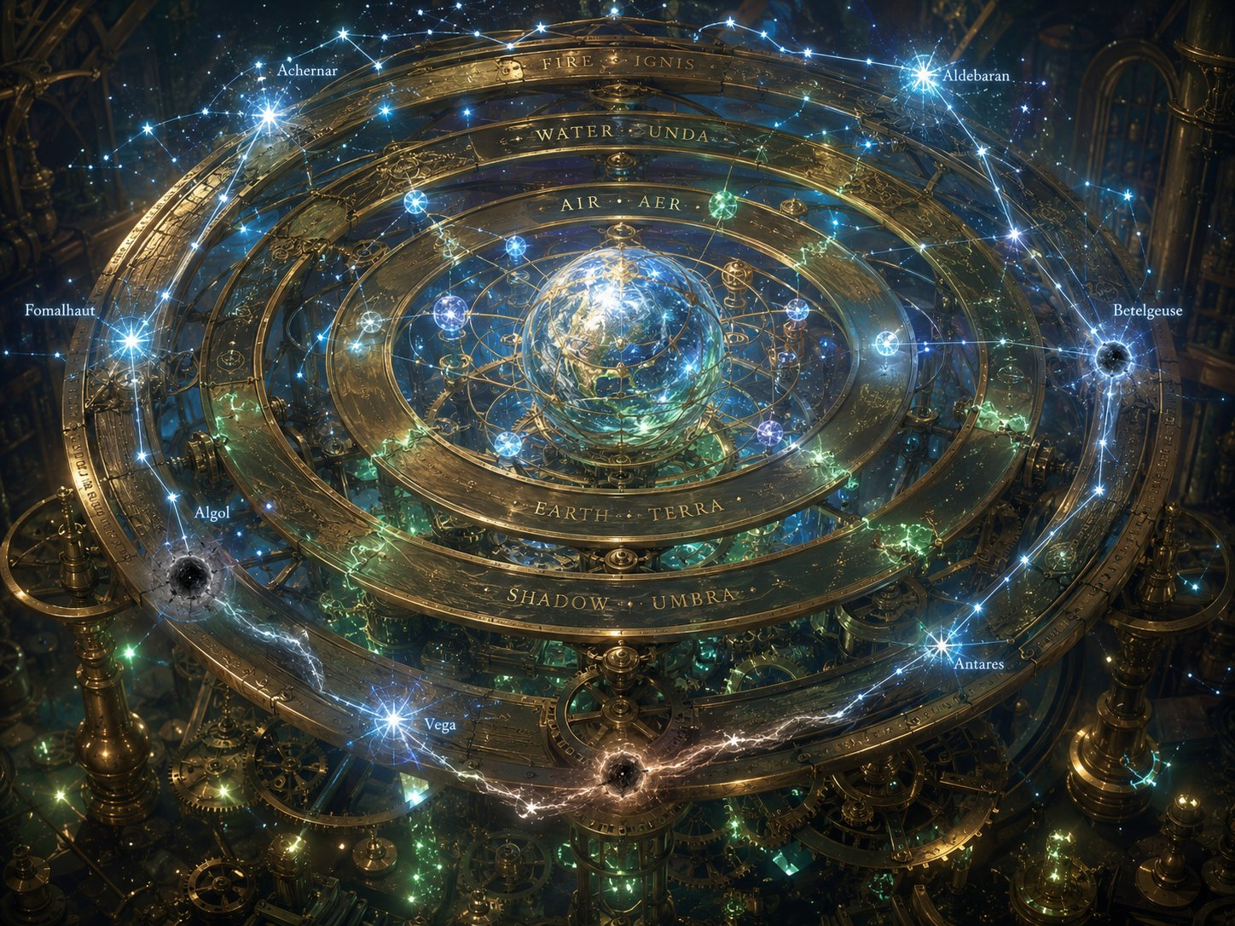
The Orrery of Planes — and the constellations that anchor it, several gone dark.

Lilly’s Moment — The What
And that’s when the Sphere moves. In Lilly’s hands, the Essence Sphere gives a violent PULSE — and lunges. It strains toward the orrery’s loose, drifting motes like a magnet yanked toward iron, so hard Lilly has to grip it with both hands. Its casing irises wider on its own, hungry, reaching — and the little crystal motes tremble in the air and begin to drift toward it.
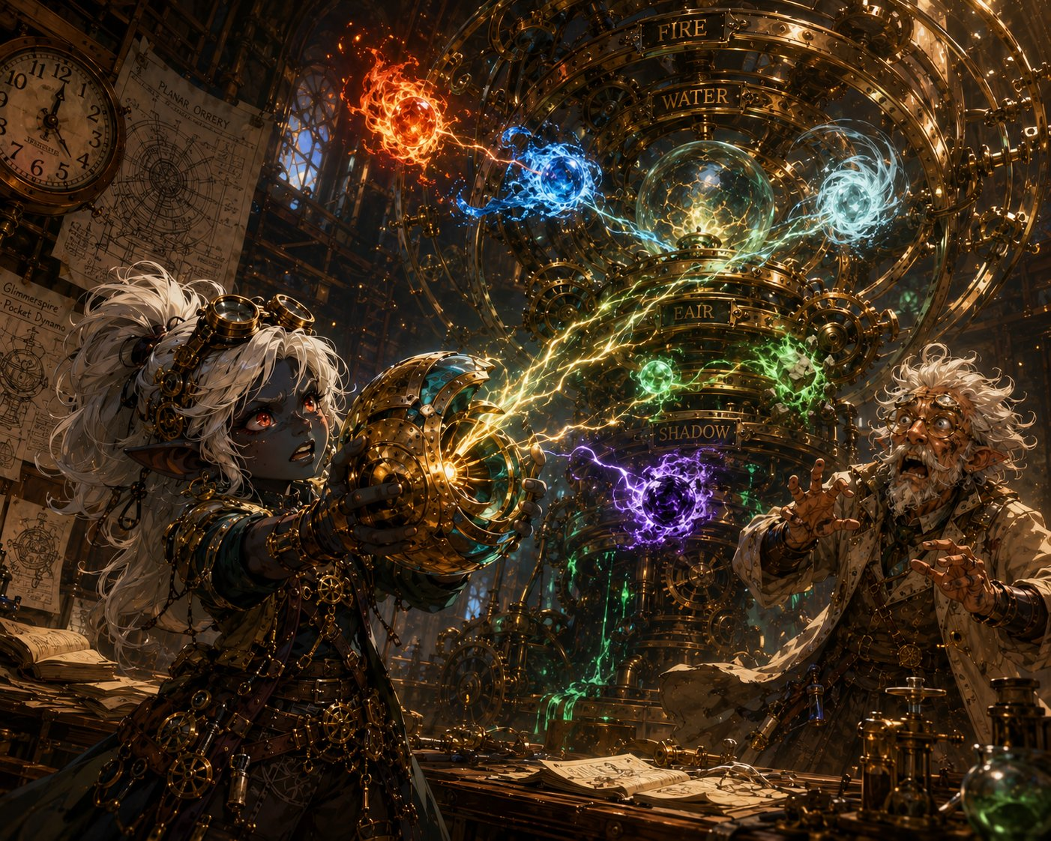
The Sphere lunges — a gatherer, reaching for the loose motes.
Vane stumbles back, mouth open. “It’s— it’s PULLING them. It’s a GATHERER. Catching planar energy. Holding it. SURVIVING it.” He points a shaking finger at the empty cradle in the heart of his folly — the socket he could never fill. “THAT is the missing piece. Ten years I have cursed that empty cradle, and you walked into my workshop with exactly the thing it was waiting for.” His voice drops to an awed whisper. “But this Sphere is OLD — older than the cracks, older than the sickness. Whoever forged it built the cure years before there was a disease. Who GAVE you this, child? They didn’t hand you a keepsake. They handed you the heart of the only machine that could save the world. And somehow… they KNEW.”
Lilly’s spotlight. Her mother, Poots, gave her the Sphere. Let her player sit with “they knew.” Thread for her time-skip path and the Pikachu mystery.

Ursa’s Moment — The Why
Lilly’s Sphere strains toward the dark leaking motes — and across the room, Ursa goes very still. Because if the Sphere reaches toward the broken places, then Ursa, who reads the sky like a map, asks the question no one else can: what BROKE them? Something his father taught him long ago scratches at the back of his mind. The way the stars hold their places. The way the whole sky is a map that never moves… unless something moves it. And then it hits him, all at once.
Give Ursa’s player the spotlight. Let the kid say it, or read the line.
Ursa: “It’s not the gears. …It’s the stars. Something’s putting them out.”
The room goes quiet. Vane blinks. “I— beg your pardon?” Ursa steps to the orrery, and now he sees what Vane never could — because Vane sees a machine, and Ursa sees the sky. As he focuses, soft starlight kindles around his staff and spills toward the great model: ghostly constellations shimmer into view above the brass rings, each plane hanging from a bright anchor-star. “The planes don’t spin on their own. They’re held — by stars. Anchor-stars, fixed points up in the dark, each holding a plane in its orbit.” He points, and you all see it now: among the bright stars, several have gone DARK. “That one isn’t wearing out. Its anchor-star has gone dark. The light that held it went out — so the plane slips, and cracks, and things fall through.” He turns, eyes wide. “The clock isn’t breaking on its own, Guildmaster. Someone is putting out the stars. One by one. And every dark star opens a new crack.”
Vane takes off his goggles. “In sixty years of study… I never once thought to look UP.”
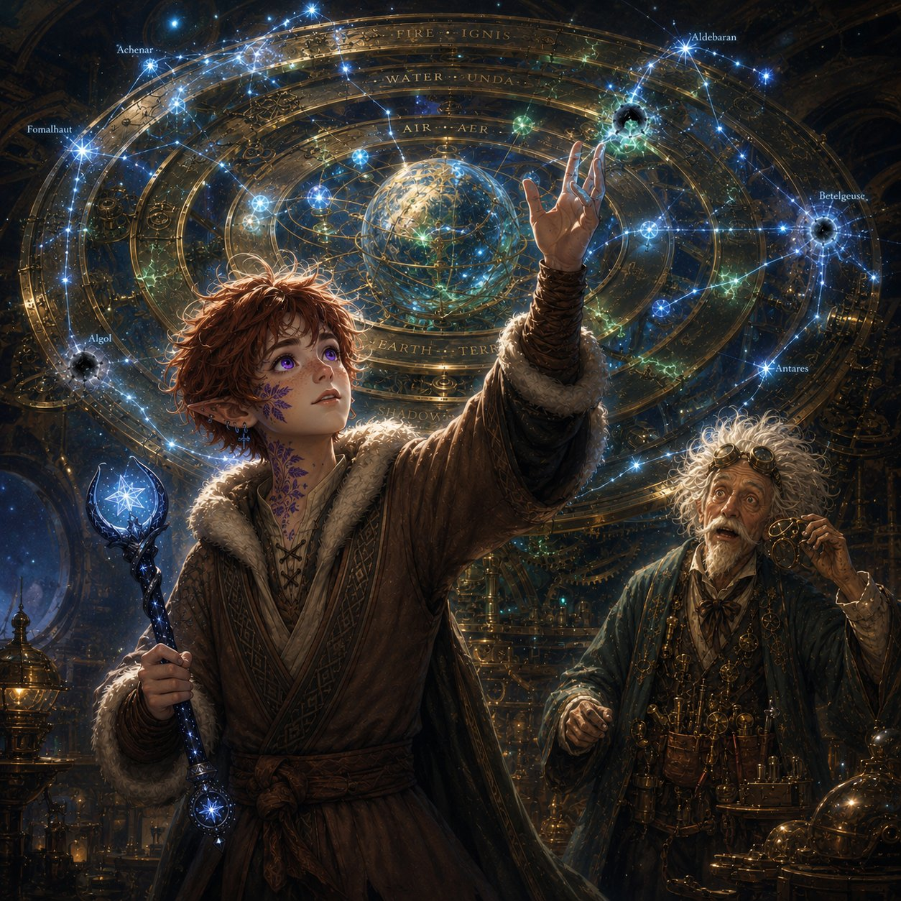
Ursa names the cause — the dying stars — and his staff answers with starlight.
Connect Ursa’s threads (let it land): His father, Ash, wasn’t chasing cracks — he was following the stars going out. And the Staff of Waking Constellations, which lights a new star after every victory, is literally the counter-weapon: the enemy puts stars OUT, the Staff lights them UP. Ursa carries the one thing built to fight back.

Ash’s Trail
Vane is still reeling — “the stars, of course” — when the name registers. “Wait. Catchum, you said? Ash Catchum?” He snaps his fingers at Quill. “That name’s in the books.” Quill is already moving. “Indeed. The traveler-logs.” The silver Mechagnome leads Ursa into the Guild’s vast archives and draws down a dusty volume, turning to a page near the back. “Here. Some years past.”
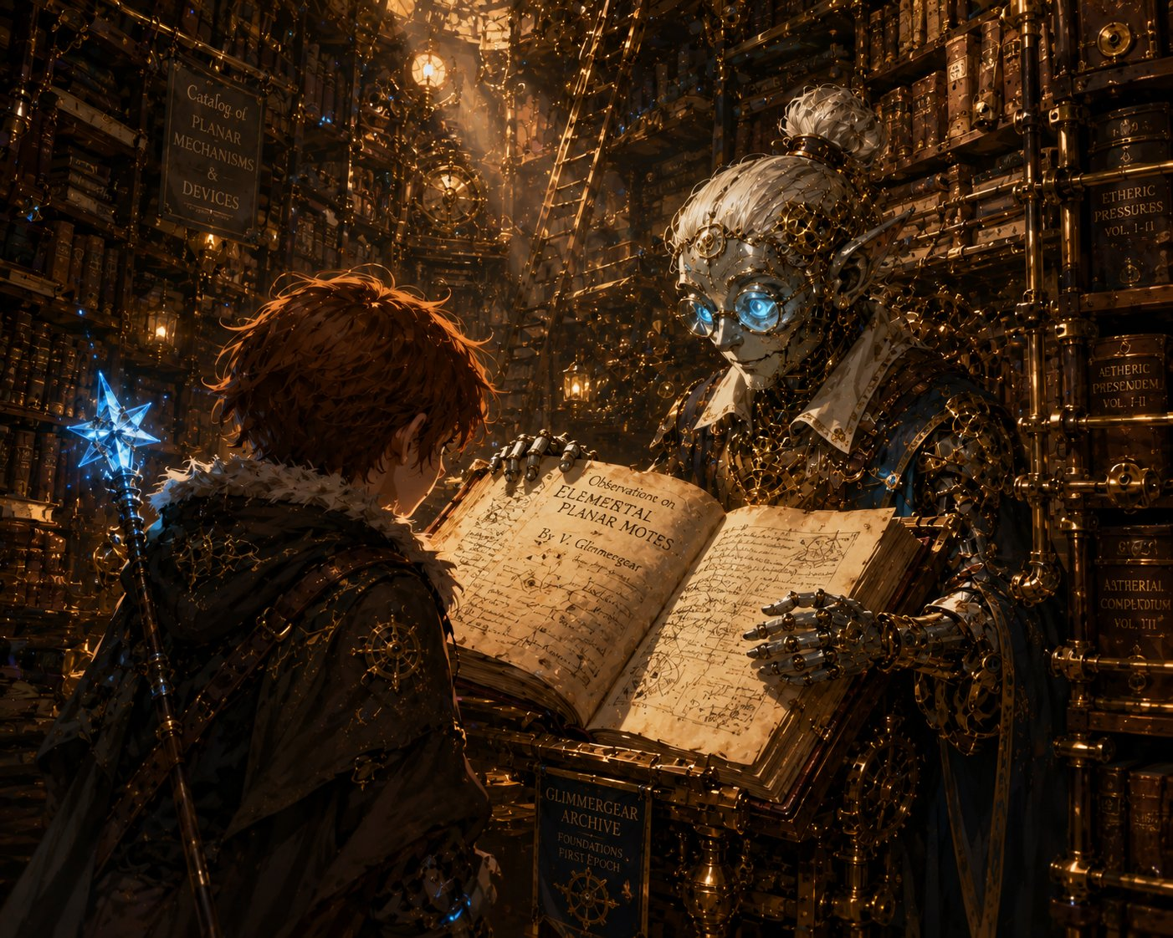
Quill leads Ursa to the archives — and his father’s logbook.
And there it is. In faded ink, in a careful, familiar hand that makes Ursa’s chest go tight — his father’s handwriting. A sky-reader named Ash Catchum, passed through Gearhaven, asking about the planar cracks and “the darkening sky.” A final margin note, hurried: “The pattern leads east. Following the dark. To the old shrine.”
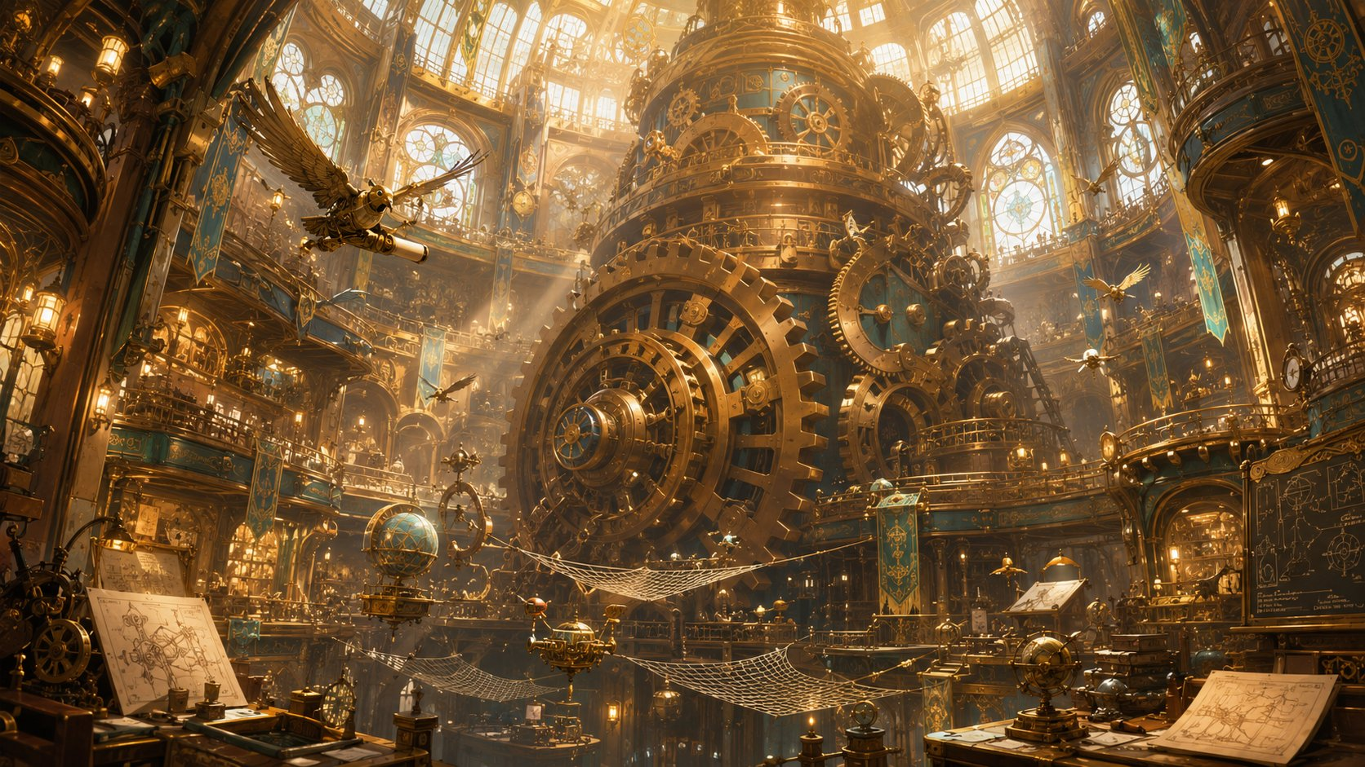
Ash’s entry — “following the dark, to the old shrine.”
Ursa’s father hook planted (his time-skip seed). Quill notes the shrine is “far to the east, beyond the maps we keep.” Let Ursa’s player sit with it.

The Guardians of Elaria
There’s a quiet after the archives. Vane sees the looks on your faces and sets down his tools. “There’s more, isn’t there. Out with it.” So you tell him. About Elaria — the sleeping goddess. The vision in the glade. The chest beneath Wraithpine and the gifts marked with her seven-pointed star, each made as if measured for your hands before you arrived. How something keeps setting your feet on this road. How you’ve started to call yourselves the Guardians of Elaria — half a joke, half because it’s begun to feel true.
Lilly: “My mother gave me the Sphere before I understood any of this. Like she knew where I’d need to take it.”
Ursa: “The staff. The visions. Something keeps… pointing us forward.”
Stabby: “We thought we were just lucky. Lucky and good-looking. But it’s more than that, isn’t it?”
At the name Elaria, Vane stops fidgeting entirely. “Elaria,” he repeats, like a word from an old song. He pulls down a slim, ancient book. “I know that name. From the old cosmologies. They called her a Warden — not a goddess of war or harvest, but of BALANCE. The one who kept the planes in their courses.” He looks up at the slipping rings. “The stories say she ‘tended the lights of heaven.’ I thought it was poetry. But you’ve shown me the lights of heaven are real, and they’re going out. Perhaps Elaria was the one who kept the stars LIT — and now that she sleeps…” He doesn’t finish. The dark stars say it for him.
Then he looks, slowly, from Lilly to Ursa to Stabby. “Chosen. Of course you were. A Sphere forged before the sickness, built to CATCH what’s falling out of the sky. A boy who reads the stars going dark — the cause behind every crack. And the three of you, drawn together across half the world and pointed straight at the heart of it.” He spreads his hands, gentle now. “I build things, children. I’ve spent ten years building a door to save the world and never once dreamed the key would simply walk through it. I’m just the locksmith. YOU are the key. A sleeping Warden, tending her failing stars even in her dreams — gathering the exact pieces needed to mend her sky, and gathering them around you three. That is not luck. That is a goddess reaching, in her sleep, for the only hands that can do what must be done.”
The Great Governor beats on beneath your feet. Boom. Boom. Boom. And for the first time, the three of you understand what you are. Not lucky travelers who keep stumbling into trouble. The Guardians of Elaria — chosen, assembled, and pointed at the very thing breaking the world.

The Descent
For a moment, no one speaks. Then Vane claps his hands, suddenly brisk and almost giddy. “Which means we have WORK to do! But everything — the portal, the motes, the whole grand business of saving creation — begins with one humble step. I need fuel. Condensed aether, drawn from the conduits beneath the city. The Underworks.” He glances toward a heavy iron hatch in the floor. “With the machines as they are, I’d never send apprentices down there now. But three chosen heroes who just saved my market…?”
Quill is already lifting a ring of keys. The hatch groans open onto a stairwell of damp stone, and a breath of cold air rises to meet you — colder than any cellar should be, threaded faint and far below with a sound none of you can name. The blue glow of the conduits flickers in the dark. Down you go.

End of Beat 3. The descent leads into Beat 4: the Underworks — a planar crack up close, the Rift-Crawlers (Fight 2), and Stabby’s hook.

